Batch Processing:

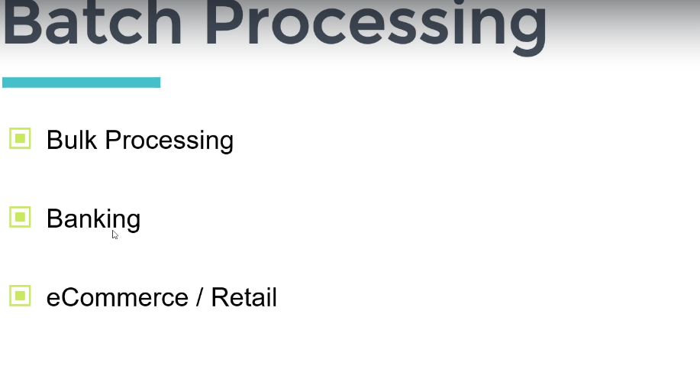

For processing Millions of records we can use of spring batch

Note: Scenario a seller upload the millions of sale record in csv file

And we need to write the same into the db or mysql

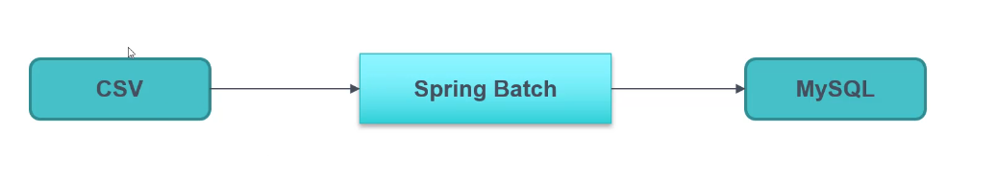

Spring batch will handle the bulk processing

# Retry & Skip Mechanism:

If we are processing a batch and one of the records get failed in a batch then we don’t to fail the entire batch instead of that we can skip those particular records.

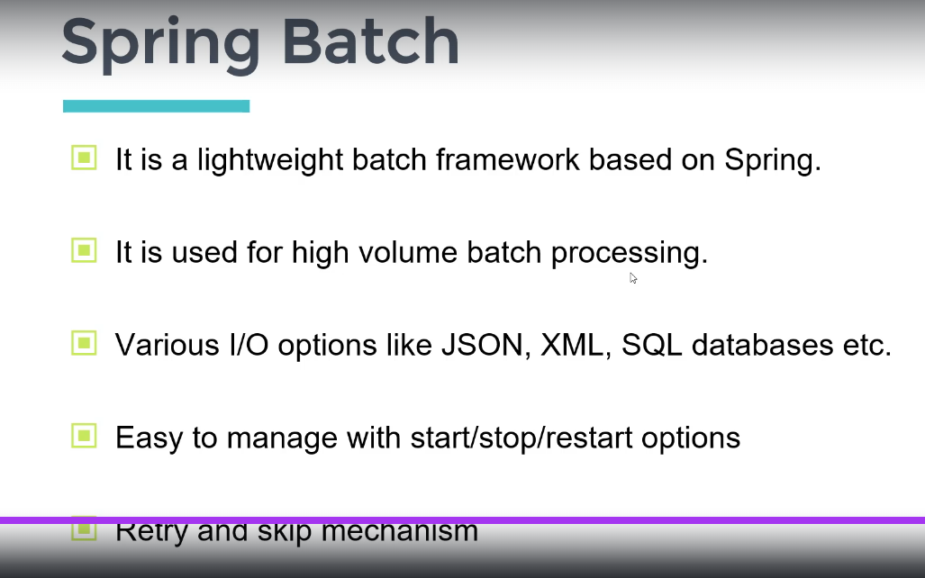

In Spring Batch we can have the transaction which we can say that a JOB

And a Job can have multiple or single steps to do

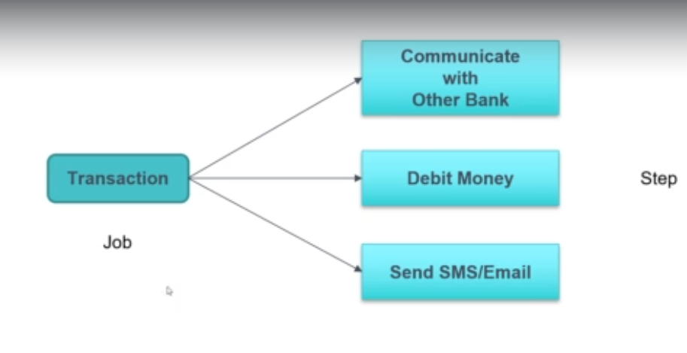

## Steps Type in Spring batch:

Spring provide 2 types of step

1. Tasklet Step
2. Chunk oriented Strep

Note: Let say we have 10k records then how we can proceed with it how we will divide the file into the chunks and we have define chunk size as 3

SO it will process 3 records at a time.

We will use Item reader for reading data from CSV and we will write data into mysql using itemWriter

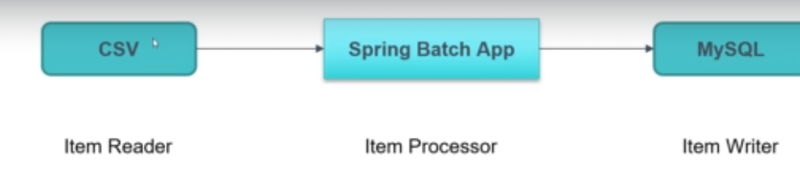

# Spring Batch Architecture:

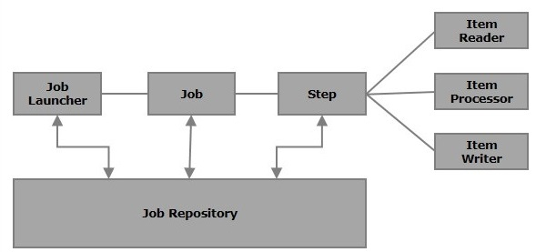

In batch we have a job that run on a daily basis

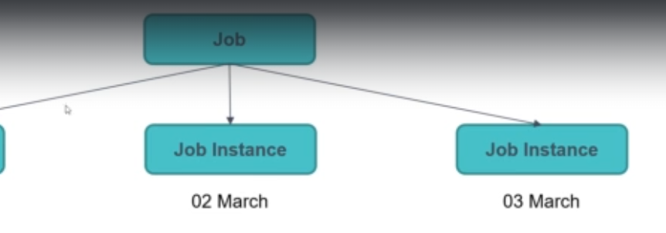

At mid night job will run that is JOB EXECUTION   
=> Success Or Failure for Job execution

If we try to run Job Instance for 1st March the it will not run as it’s comes into the delicacy.

If the failure

# Make Job Parameter Unique:

If we run the same job again and again then in the meta db table we already have that job with status as COMPLETED if we try to run the same job again then our program will fail.   
  
So the solution we will propose is new RunIncrementId();

# Job Listener:

Intercept the request before and after the job: